

LAB MANUAL
PROGRAMMING FOR AI
AI-212

Submitted by: Muhammad Masood Bakhtiar
Submitted to : Mr. SAMRAIZ
Registration no : 2023-bs-ai-056
Degree : Artificial Intelligence (5A)

DEPARTMENT OF COMPUTER SCIENCES

TABLE OF CONTENTS

Lab 01 – Programming fundamentals of python………………………………………….3

Lab 02 – Object oriented programming in python………………………………..………21

Lab 03 – Numpy in python………………………………………………………………...40

Lab 04 –Seaborn and scikit learn…………………………………………………………52

Lab 05 –Tensorflow in python ………………………………………………………………65

LAB NO 1:
Programming fundamentals of python
Q1. Banking Transaction Validator with PIN
Simulate a bank ATM.
User enters a 4-digit PIN (check if valid).
Display account balance and ask for withdrawal amount.
If valid → deduct + update balance.
If invalid attempts ≥ 3 → block card.
Use operators to compute service charges (2% per withdrawal).

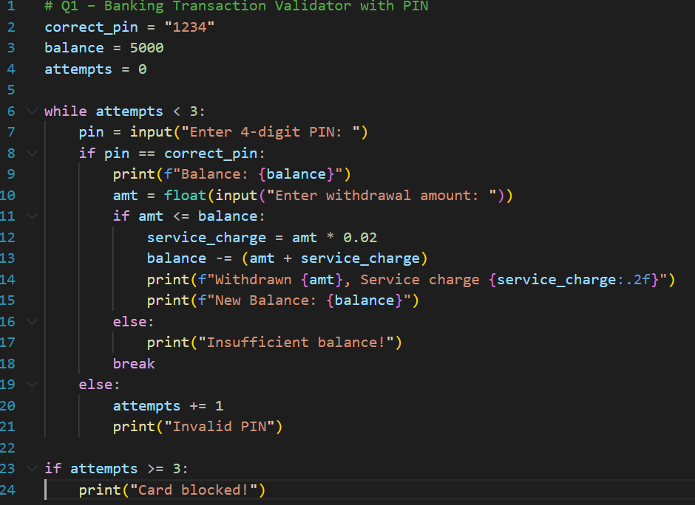
Output:

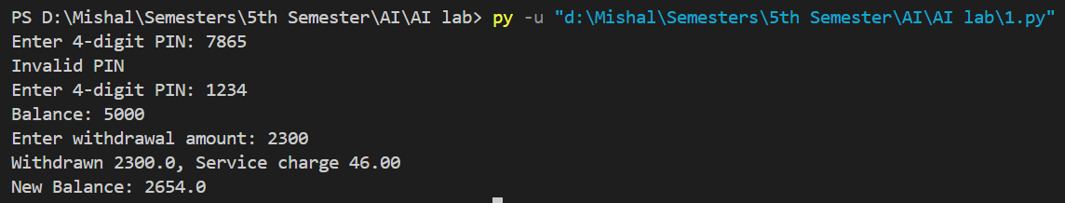

Q2. Grocery Store Inventory System
Maintain item names, stock, and prices in a dictionary of dictionaries.
User selects items with quantity.
If stock available, deduct from inventory.
Apply discount slabs (10%, 15%, 20%).
Print final bill with tax (5%).

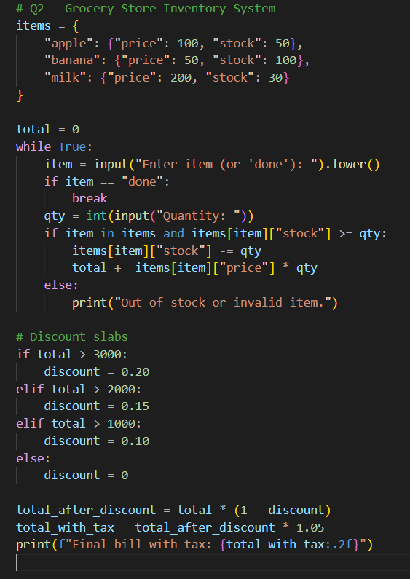
Output:
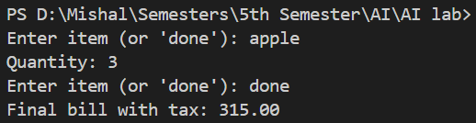

Q3. Student Grading with Subject Weightage
Input marks for 5 subjects where each subject has different weightage (stored in a tuple).
Compute weighted average.
Assign grade (A/B/C/D/Fail).
Also, display whether the student is eligible for scholarship (≥80% weighted).

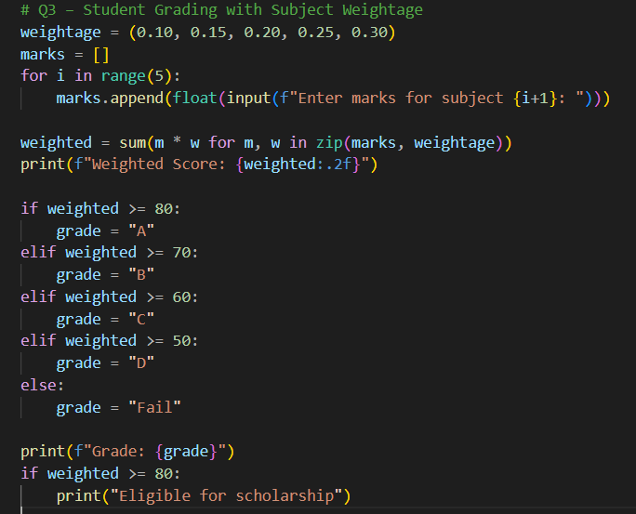
Output:

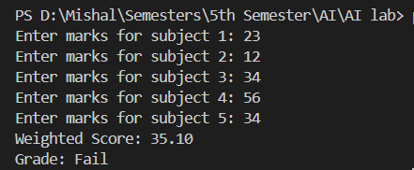

Q4. BMI + Health Recommendation
Extend BMI program:
Take weight, height, and age.
Compute BMI.
Based on BMI and age, give personalized health suggestions (e.g., diet plan for obese, exercise plan for underweight).

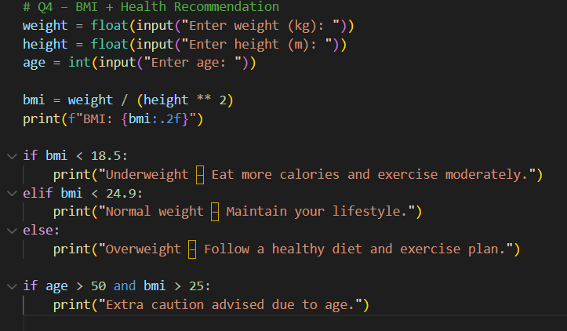
Output:

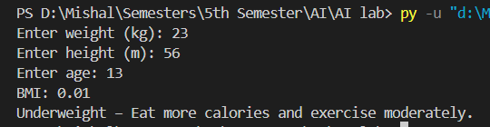

Q5. Telecom Prepaid Recharge System
Maintain call rate/min, SMS rate, and data/MB in a dictionary.
User selects usage (calls, SMS, data).
Deduct accordingly from balance.
If balance < 20% of initial → print recharge reminder.
Apply bonus balance if recharge > 1000.
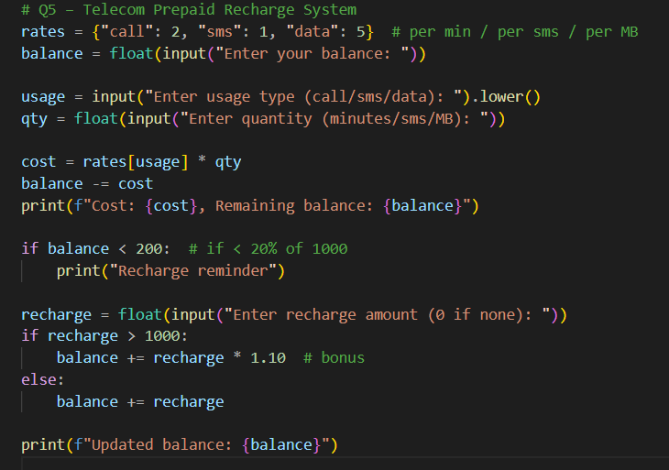
Output:

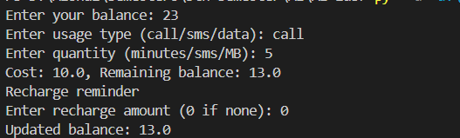

Q6. E-Commerce Discount Engine with Membership Levels
User inputs bill amount + membership type (Regular, Gold, Platinum).
Apply different discount rules (Gold +10%, Platinum +15%).
If bill > 10000, apply additional 5% flat.
Show itemized receipt with tax breakdown.

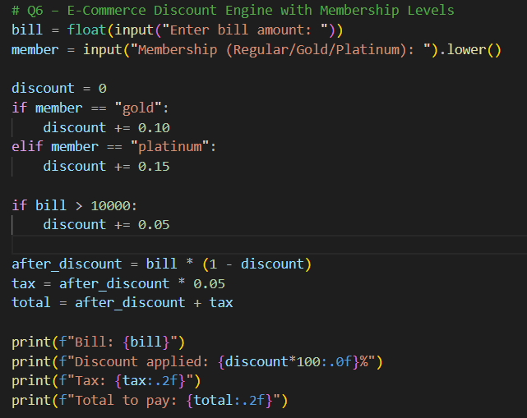
Output:

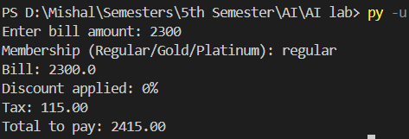

Q7. Hospital Emergency Unit with Multi-Condition Triage
Take patient details: temperature, pulse, oxygen, blood pressure.
Classify into categories: Stable, Observation, Urgent, Critical.
If critical → suggest “Admit in ICU.”
If urgent → suggest “Immediate doctor attention.”
Use nested conditions.

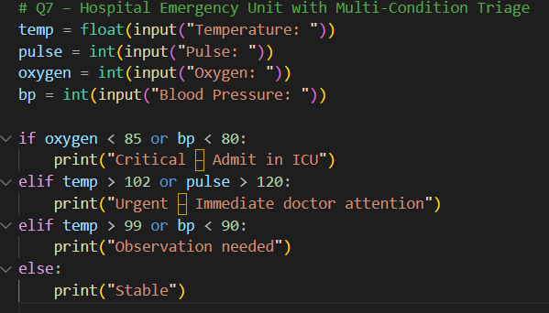
Output:

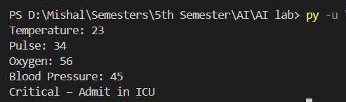

Q8. Online Examination Grader with Negative Marking
Take total marks, obtained marks, and number of wrong answers.
Deduct 0.25 per wrong answer.
Compute percentage.
Assign division + eligibility for scholarship.
If Fail → suggest "Repeat Exam."

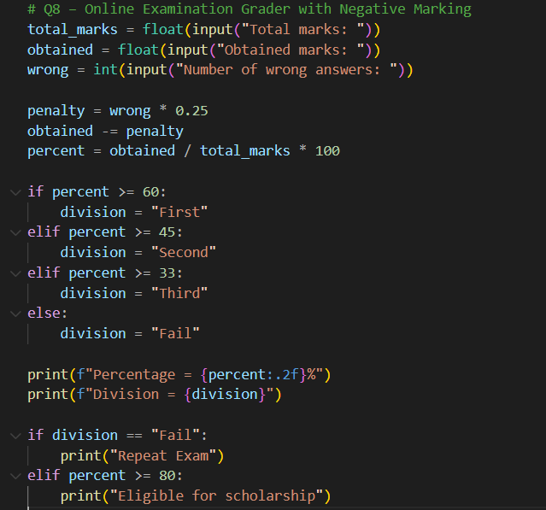
Output:

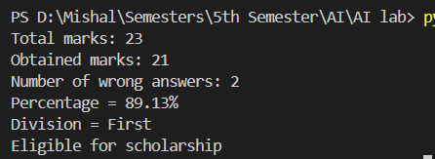

Q9. Movie Ticket Booking with Age & Timing Policy
User inputs: age, showtime, ticket type (Normal/3D/IMAX).
Apply child restrictions (No late-night for <12).
Apply senior citizen discount (30%).
Apply peak hour charges (10%).
Print final ticket price.

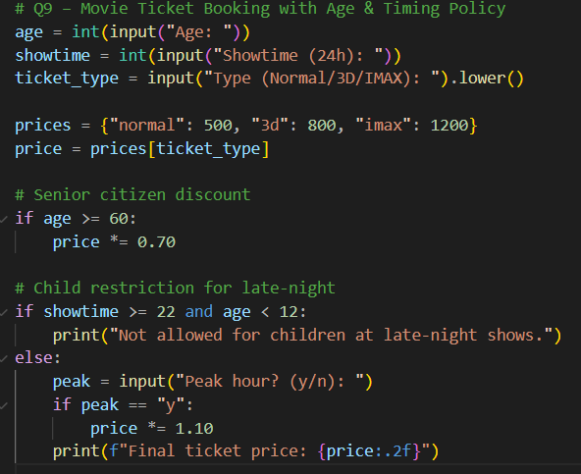
Output:

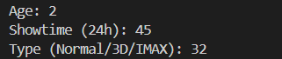

Q10. Weather-based Outfit + Travel Suggestion
Input temperature, weather (Rainy/Sunny/Cold), event type (Casual/Business/Party).
Suggest outfit + accessories.
If Rainy → umbrella; If Cold → gloves.
If event is Business + temperature > 35 → recommend “light formal suit.”

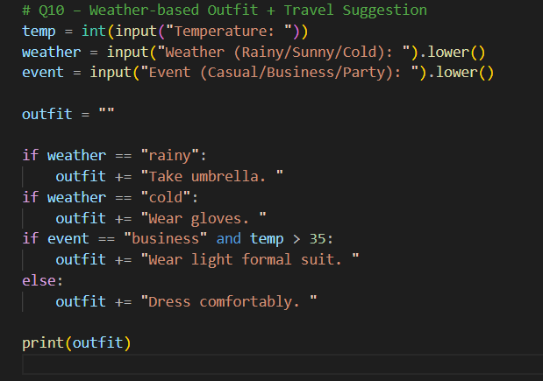
Output:

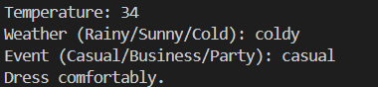

Q11. ATM Withdrawal with Note Counting + Receipt
Take withdrawal amount.
Compute minimum number of notes (1000, 500, 100, 50, 10, 1).
Also compute service charge = 0.5%.
Print receipt with remaining balance after deduction.

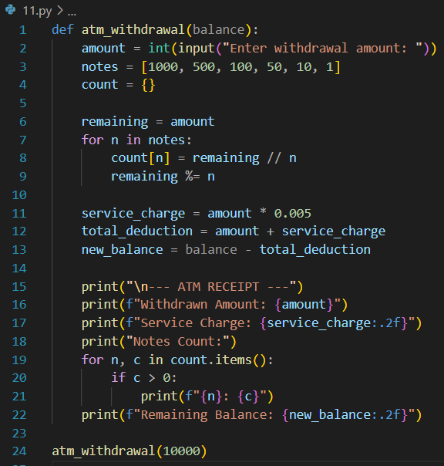
Output:

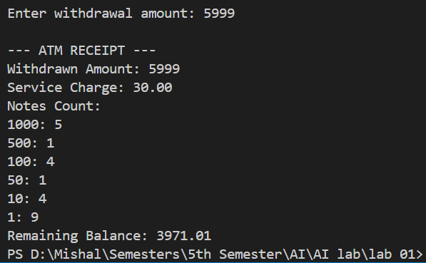

Q12. Library Fine Calculator with Membership Levels
Input days late.
Apply fines (10, 20, 50/day).
If days > 30 → “Membership Cancelled.”
If user is Premium member, reduce fine by 50%.
Print detailed fine slip.

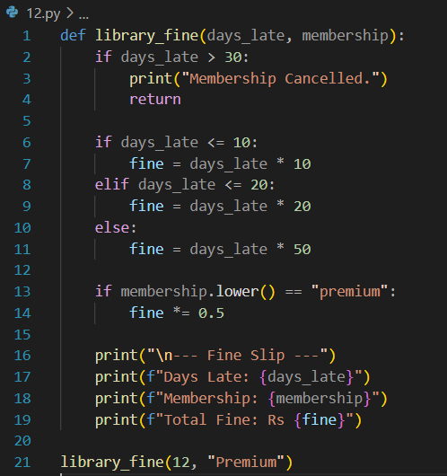
Output:

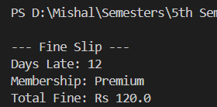

Q13. Sales Analysis Dashboard
Store monthly sales in a list (12 entries).
Print max, min, average.
Print months above average.
Use loop + condition to print “Growth” or “Decline” compared to last month.

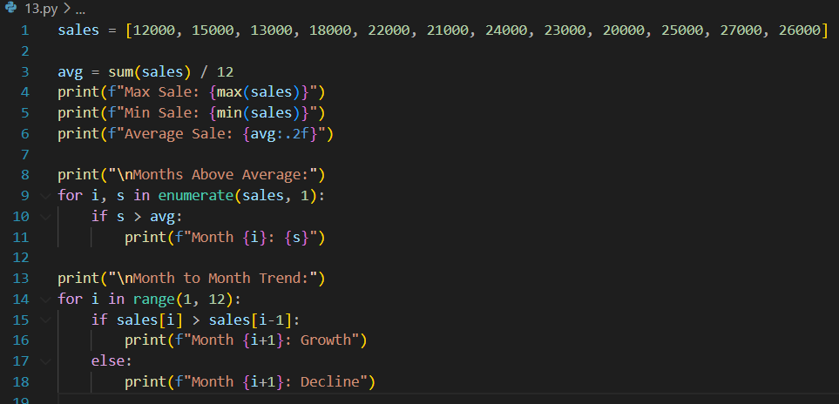
Output:

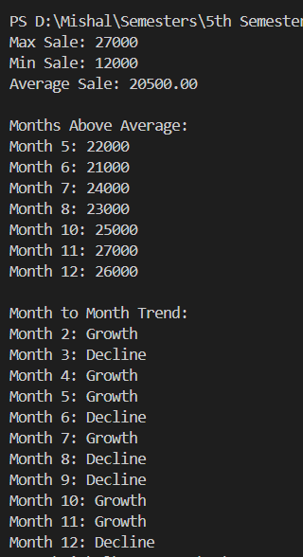

Q14. Multiplication Puzzle with Random Blanks
Generate a multiplication table (1–10).
Randomly replace 3 results with "??".
Ask user to guess values.
Track score.
Give performance remark (Excellent/Good/Try Again).

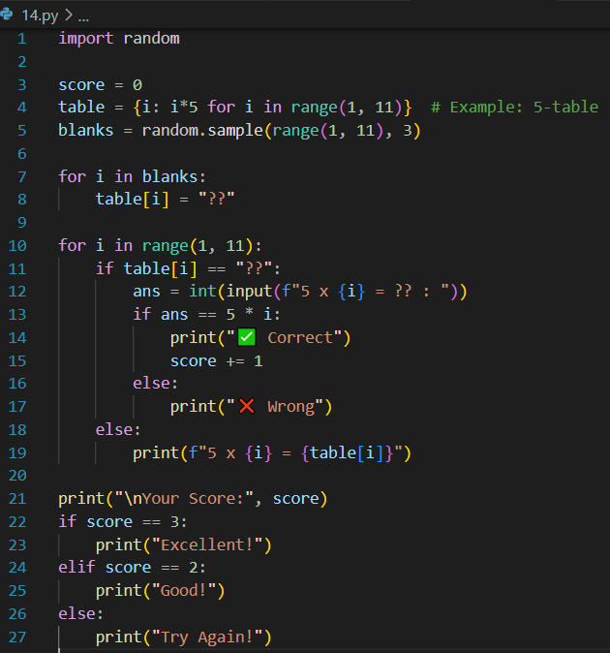
Output:

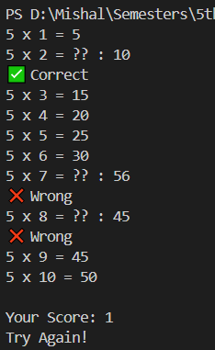

Q15. Password Strength + Re-entry Attempts
Check password rules (length, digit, upper, lower, special).
If weak → ask user to re-enter.
Allow max 3 attempts.
If still weak → “Account Locked.”

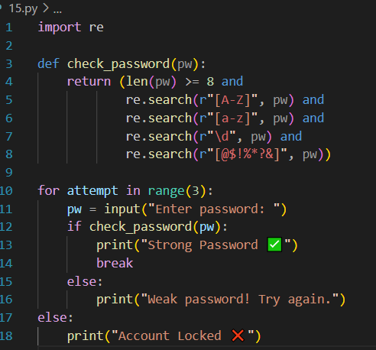
Output:

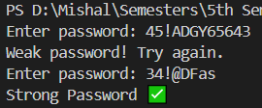

Q16. Electricity Bill with Slabs & Penalty
Function calculate_bill(units, late_payment=False):
Apply slab rates (5/7/10 Rs).
If late_payment → add 15% penalty.
Return bill breakdown.

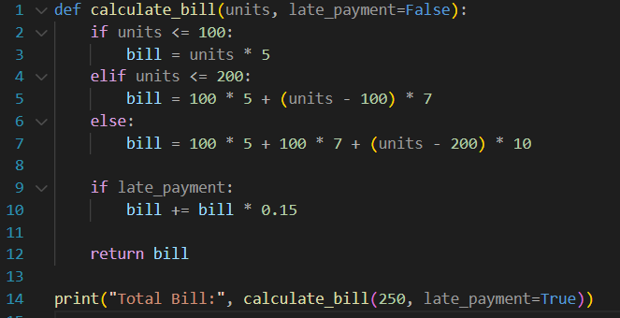
Output:

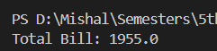

Q17. Cricket Match Predictor with Multiple Conditions
Function predict_score(runs, balls, wickets, overs_left):
Compute strike rate & run rate.
If run rate < 5 and wickets > 6 → “Losing.”
If run rate > 7 and wickets < 5 → “Winning.”
Else → “Balanced.”

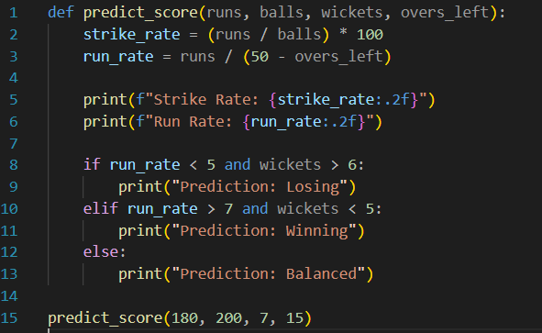
Output:

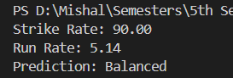

Q18. Hotel Booking with Tax & Discount
Function book_room(type, days, is_member):
Standard: 2000/day, Deluxe: 4000/day, Suite: 6000/day.
If days > 7 → 20% discount.
If member → extra 10% discount.
Add 12% tax.
Return bill slip.

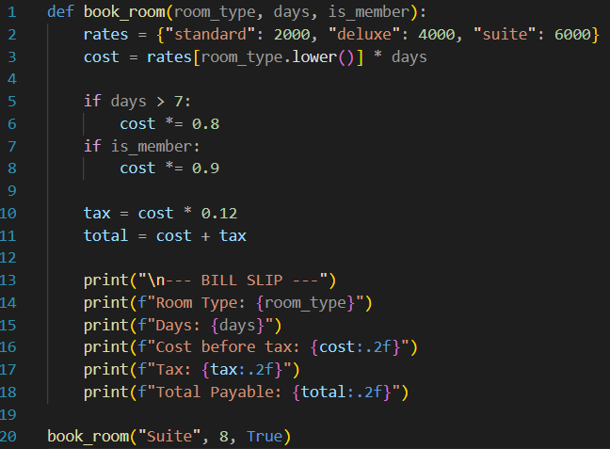
Output:
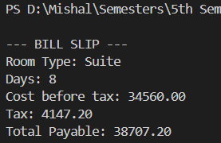

Q19. Flight Fare Calculator with International Tax
Function calculate_fare(distance, class_type, international=False):
Economy: 10/unit, Business: 25/unit, First: 40/unit.
Add fuel surcharge 500.
If international → add 18% tax.
If booking in advance (>30 days) → 10% discount.

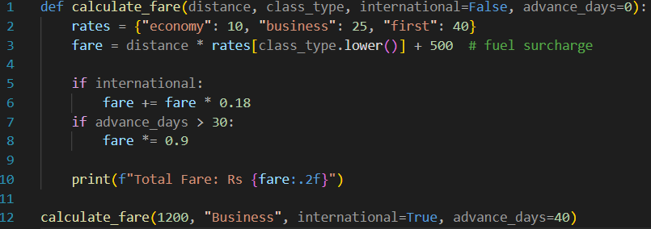
Output:

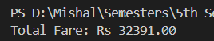

Q20. Smart Vending Machine with Wallet System
Function vending_machine(item, amount_paid, wallet_balance):
Items stored in dict with stock + price.
If sufficient → dispense + return change.
Update wallet balance.
If stock = 0 → suggest alternative item.

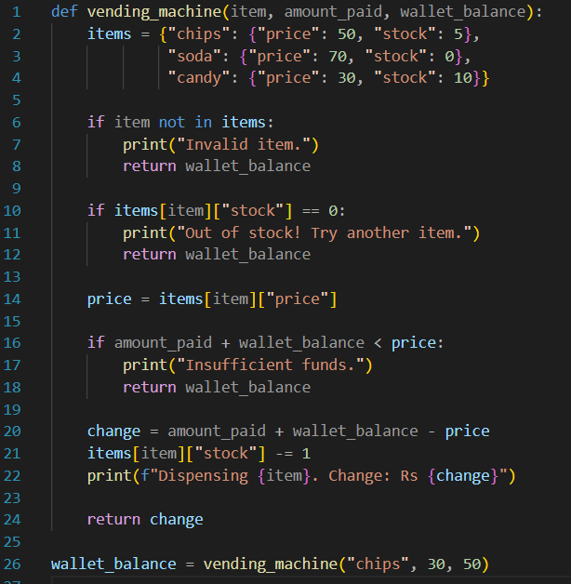
Output:
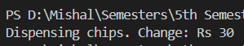

Lab NO 2
Object oriented programming in python
Question # 1:
Create a `Bank Account` class that represents a bank account. It should have attributes for account number, account holder name, and balance. Include methods to deposit, withdraw, and display balance. Ensure withdrawals cannot exceed the available balance.

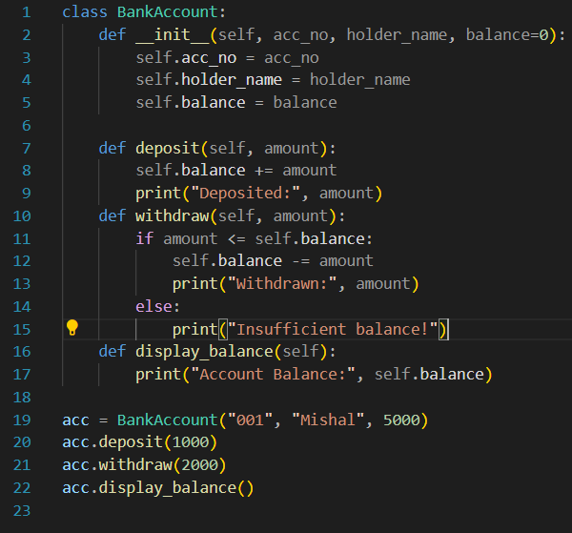
Output:
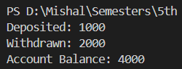

Question # 2:
Design a `Book` class with attributes like title, author, ISBN, and availability status. Create a `Library` class that can add books, search for books by title/author, check out books, and return books. Track which books are currently available.

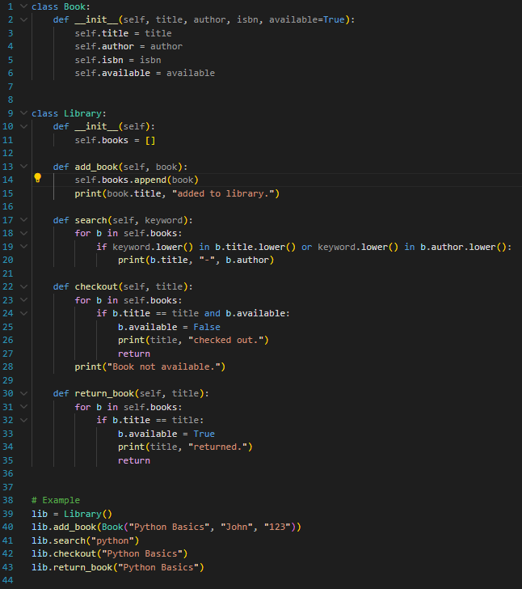
Output:
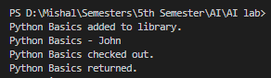

Question # 3:
Create a `Student` class with attributes for student ID, name, and a list of grades. Implement methods to add grades, calculate average grade, and determine the letter grade (A, B, C, etc.). Add a method to display student information with their performance summary.

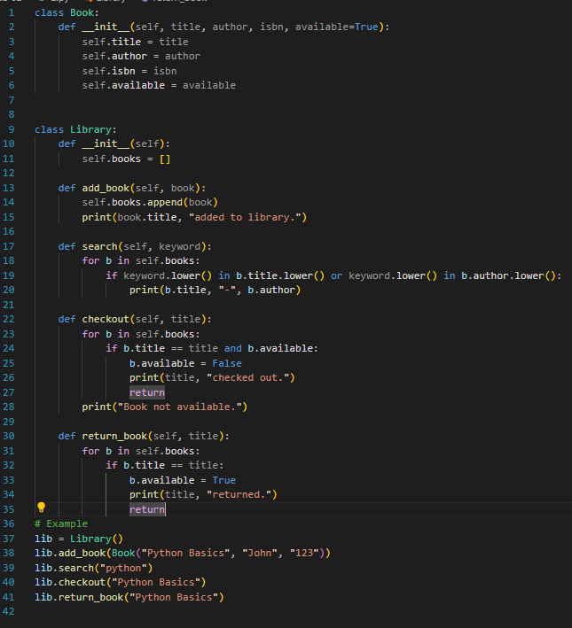
Output:


Question # 4:
Design a `MenuItem` class for food items (name, price, category) and an `Order` class that can add multiple items, calculate total cost, apply discounts, and generate receipts. Include tax calculation functionality.

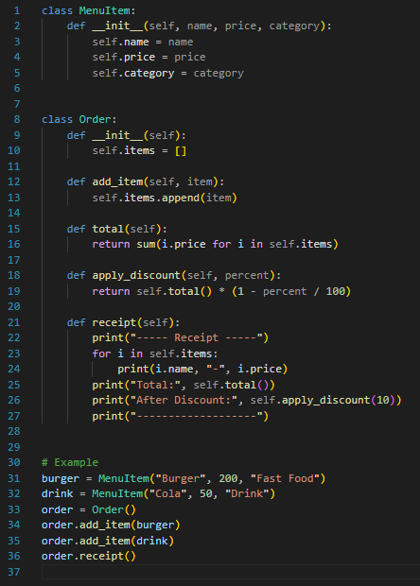
Output:
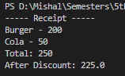

Question # 5:
Create classes for `Vehicle` (base class) and derived classes `Car`, `Motorcycle`, and `Truck`. Each vehicle should have attributes like license plate, model, rental price per day, and availability. Implement a system to rent vehicles and calculate rental costs.

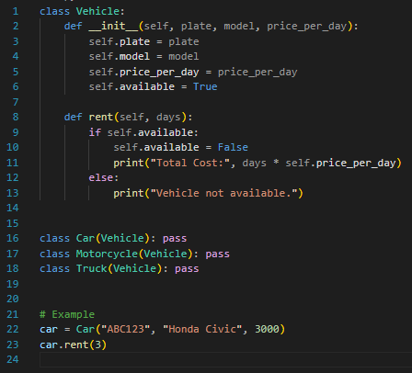
Output:
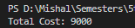

Question # 6:
Design an `Employee` class with attributes for employee ID, name, position, and salary. Create methods to calculate monthly salary, annual salary, and apply raises. Include functionality to track employee details and employment duration.

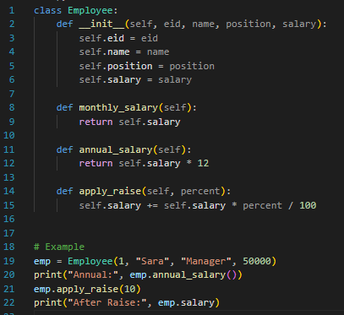
Output
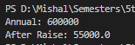

Question # 7:
Create a `Product` class with attributes for product ID, name, price, and stock quantity. Design a `Shopping Cart` class that can add products, remove products, calculate total cost, and handle checkout process while updating inventory.

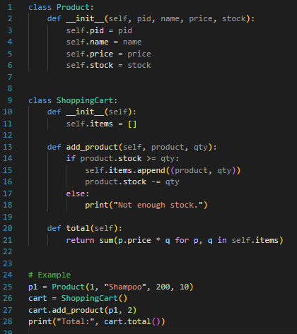
Output:

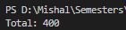

Question # 8:
Design a `Patient` class to store patient information (ID, name, age, medical history) and an `Appointment` class to manage doctor appointments. Include functionality to schedule, cancel, and view appointments.

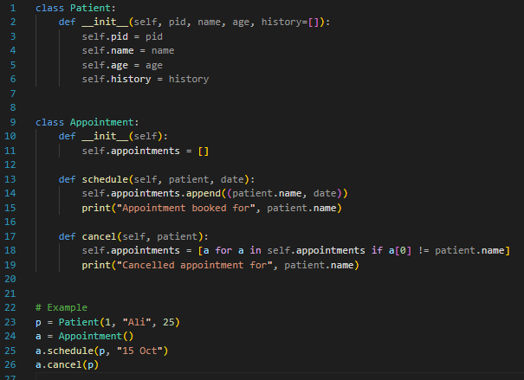
Output:

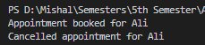

Question # 9:
Create a `User` class for a social media platform with attributes for username, email, friends list, and posts. Implement methods to add friends, create posts, and display user timeline. Include privacy settings for posts.

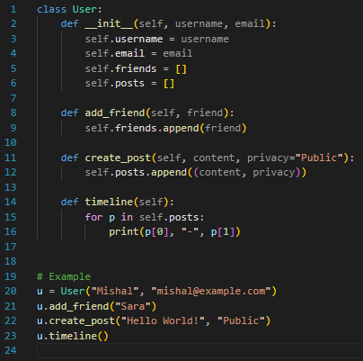
Output:
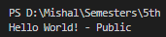

Question # 10:
Design a `Room` class with room number, type (single/double/suite), price, and availability. Create a `Booking` class to handle room reservations, check-in/check-out dates, and calculate total stay cost.

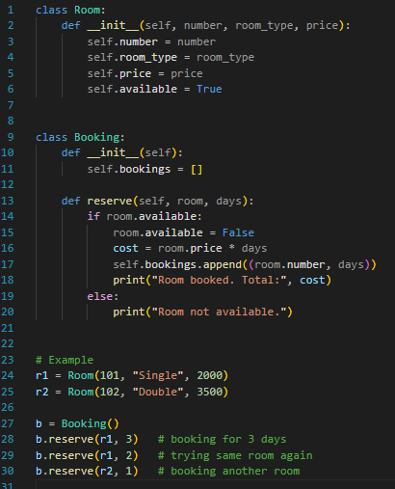
Output:
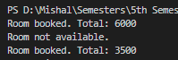

Question # 11:
Create `Course` classes (with code, name, credits, capacity) and a `Student` class that can register for courses. Implement functionality to check for schedule conflicts and ensure students don't exceed credit limits.

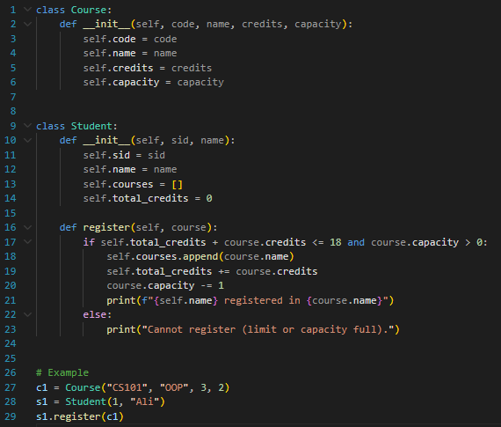
Output:
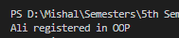

Question # 12:
Design a `Product` class for items in inventory (ID, name, quantity, price, supplier) and an `Inventory` class to track stock levels, add new products, update quantities, and generate low-stock alerts

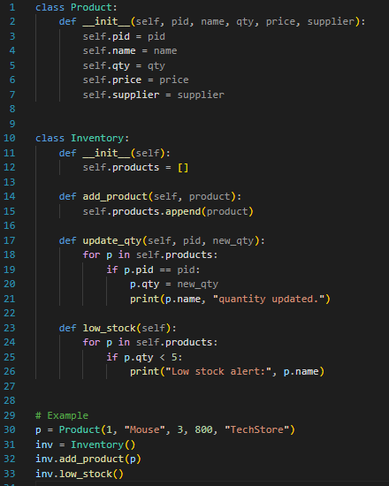
Output:

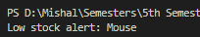

Question # 13:
Create `Movie` classes (title, genre, duration, show times) and a `Theater` class with seating arrangement. Implement a booking system that reserves seats and calculates ticket prices with different categories (standard, premium).

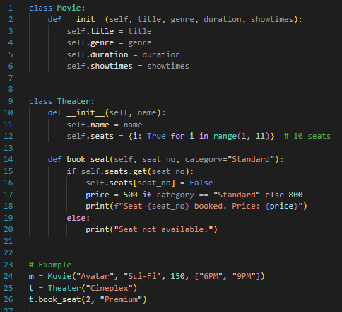
Output:
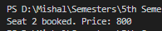

Question # 14:
Design a `Member` class with personal details, membership type (basic/premium), and attendance records. Create a `Trainer` class and a system to schedule training sessions between members and trainers.

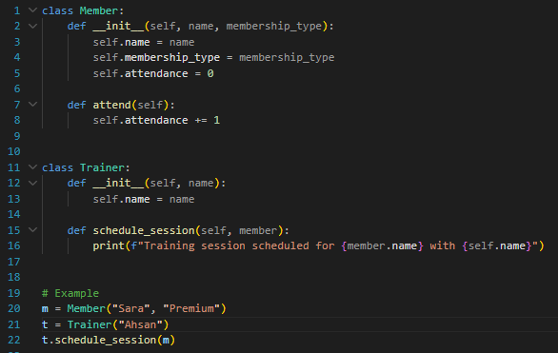
Output:

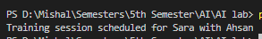

Question # 15:
Extend the bank account system to include `SavingsAccount` and `CheckingAccount` classes with different interest rates and withdrawal rules. Implement fund transfer between accounts.

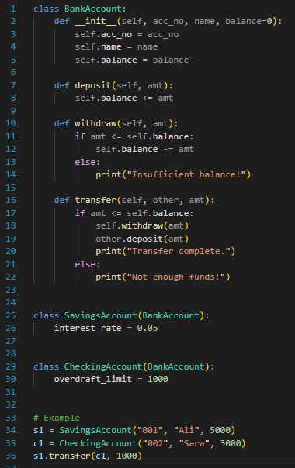
Output:

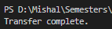

Question # 16:
Create a `Pizza` class with size, crust type, and toppings. Design an ordering system that calculates prices based on selections and allows custom pizza creation with various topping combinations.

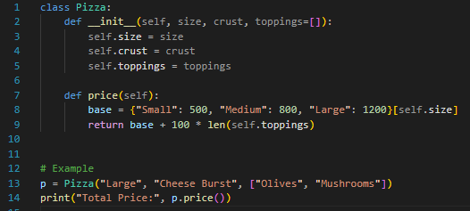
Output:

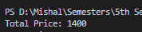

Question # 17:
Design classes for `Car` (model, year, color, price) and `CarManufacturer` that can produce different car models with various features. Include quality control checks and production tracking.

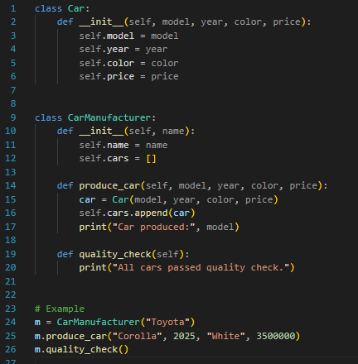
Output:

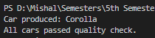

Question # 18:
Create `Teacher` and `Student` classes, and a `Classroom` class that manages assignments, grades, and attendance. Implement functionality to track student performance and generate class reports.

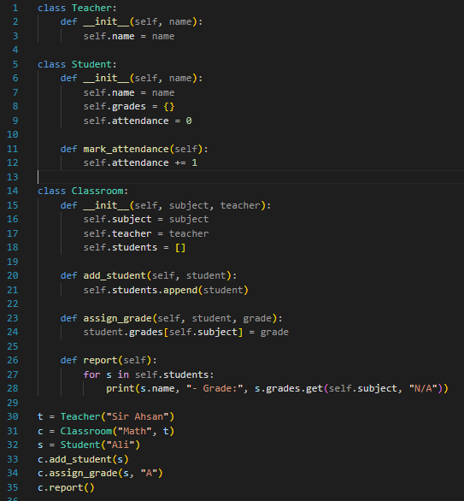
Output:
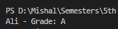

Question # 19:
Design `Flight` classes (flight number, destination, departure time, capacity) and a `Passenger` class. Create a booking system that reserves seats and manages passenger manifests.

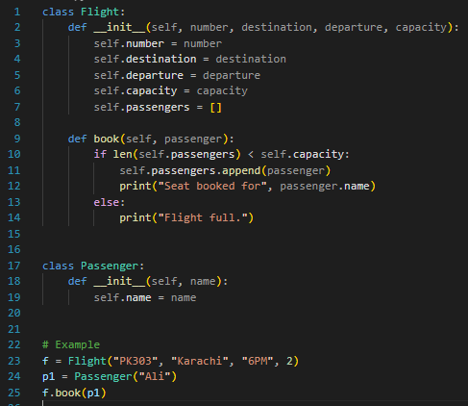
Output:

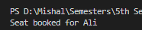

Question # 20:
Create classes for `SmartDevice` (base class) and specific devices like `SmartLight`, `Thermostat`, and `SecurityCamera`. Implement a `SmartHome classthat can control all devices and create automation routine

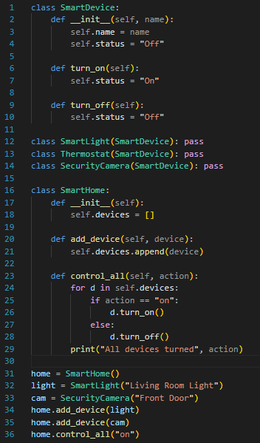
Output:

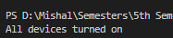

Lab NO 3
Numpy in python
What is NumPy?
NumPy (Numerical Python) is a Python library used for numerical and scientific computing. It provides powerful tools to work with arrays and matrices and perform mathematical operations efficiently.
Key Features:
- Provides multi-dimensional arrays (ndarray) instead of Python lists.
- Supports mathematical operations like addition, subtraction, multiplication, and more on arrays.
- Includes functions for linear algebra, statistics, random numbers, and Fourier transforms.
- Much faster than using Python lists for large datasets.
How NumPy Works
- Create arrays: Replace lists with arrays for better performance.
- Perform operations: Can perform element-wise operations without loops.
- Use built-in functions: Many ready-made functions for math and statistics.

Question 1:
A weather station records temperatures (°C) for 7 days:
[21.1, 23.4, 19.8, 25.0, 26.5, 24.1, 22.0]
Task:
- Convert the list into a NumPy array
- Find:
  - Average temperature
  - Maximum and minimum temperature
  - Temperature difference (range)

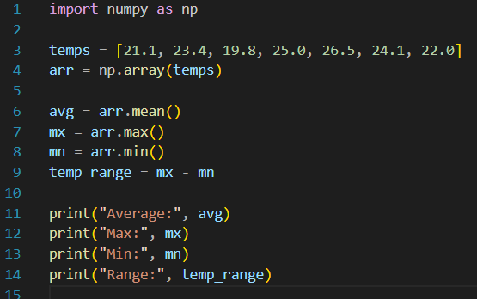
Output:

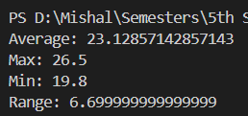

Question 2: A fruit store records daily sales of apples for 4 weeks:
Task:
- Create a 4×7 NumPy array
- Find weekly totals
- Find the highest sale day (index only)
- Find the week with the most sales

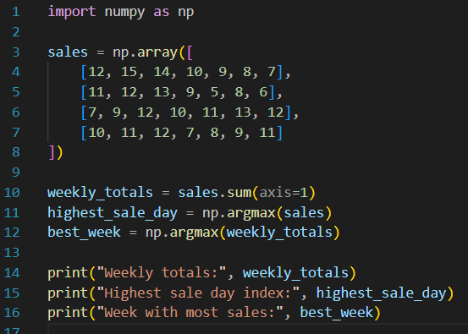

Output:

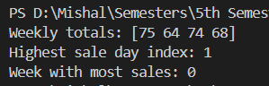
Question 3:
Students received marks in a test:
[56, 78, 45, 90, 88, 76, 59, 62]
Task:
- Convert to NumPy array
- Add 5 bonus marks to every student using broadcasting
- Count how many students now scored > 60
- Find the median and standard deviation

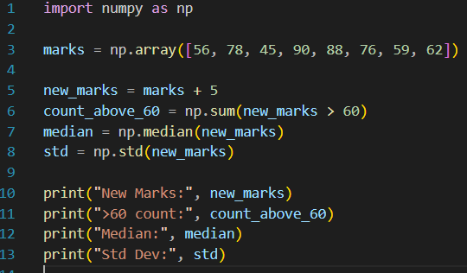

Output:
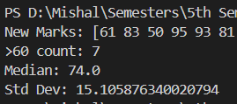

Question 4:
A smartwatch stores daily step-counts for a user for 30 days.
Task:
- Generate a random NumPy array of shape (30,) with values between 2000–15000
- Reshape into a 5×6 matrix
- Find:
  - Weekly average steps
  - Day with maximum steps
  - Number of days user crossed 10,000 steps

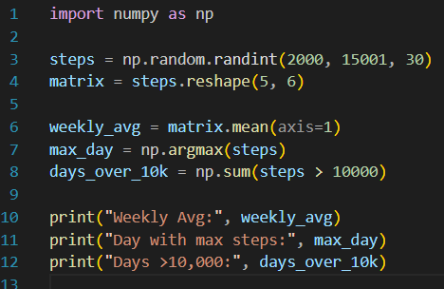
Output:

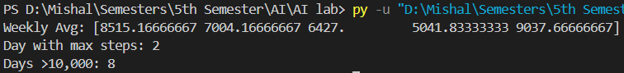
Question 5:
Task:
- Create an integer array using np.random.randint(60,150,(10,4))
- For each patient:
  - Compute daily average
  - Identify abnormal readings > 120
- For all patients:
  - Compute overall maximum and minimum
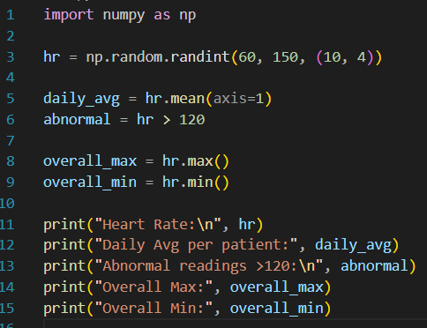
Output:
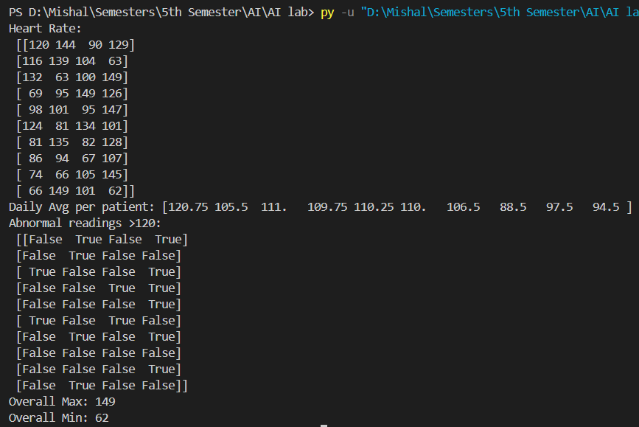
Question 6:
Two branches of a store record monthly sales (in thousands):
Branch A: [122, 135, 150, 160, 155, 140]
Branch B: [110, 130, 148, 165, 158, 145]
Task:
- Compute difference between branches
- Calculate:
  - Average monthly sales of each branch
  - Which branch performed better overall?
- Compute correlation between A and B
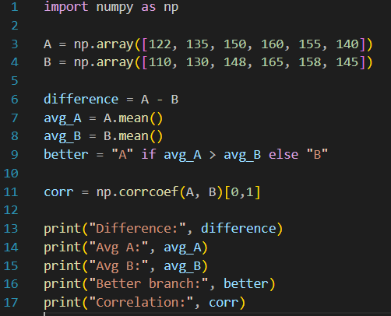
Output:
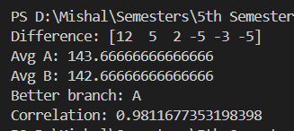
Question 7:
Given a 4×4 grayscale image:
Task:
- Convert to NumPy array
- Normalize pixel values (0–1)
- Apply a transformation: new_pixel = pixel * 1.2
- Clip all values > 255
- Compute average brightness before & after transformation
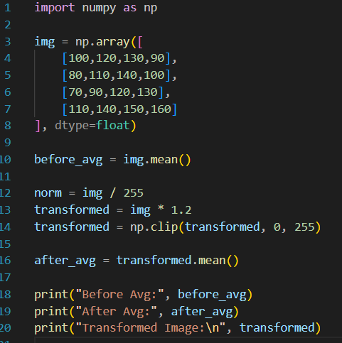
Output:
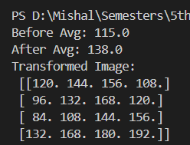
Question 8:
Dataset contains 100 samples with 4 features each.
Task:
- Generate a 100×4 matrix with values 1–100
- Standardize the dataset using:
- x_scaled = (x - mean) / std
- Perform:
  - Column-wise mean (should be ≈ 0)
  - Column-wise variance (should be ≈ 1)
- Verify results using NumPy functions
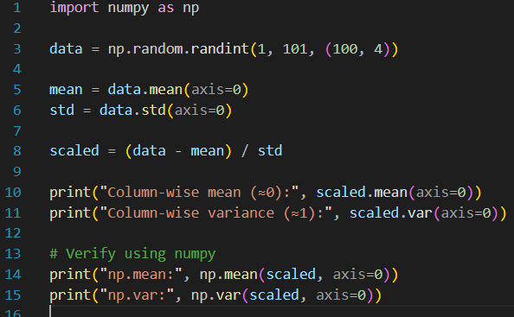
Output:
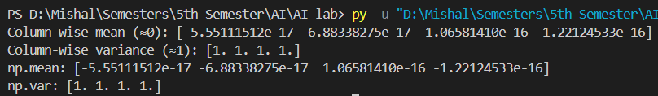

Question 9:
Simulate traffic density (cars per minute) recorded by 6 sensors over 24 hours.
Task:
- Generate array shape (24, 6)
- Find hourly average
- Identify the busiest sensor (highest total density)
- Apply a threshold:
  - Replace all values above 50 with 50 (traffic cap)
- Compute energy usage:
energy = Σ(sensor_density × 0.5)
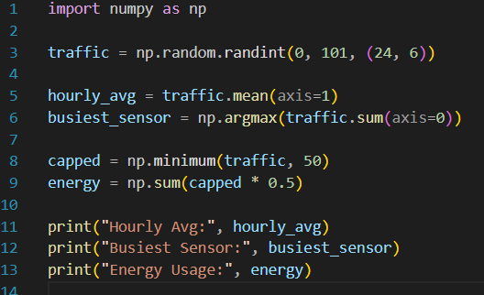
Output:
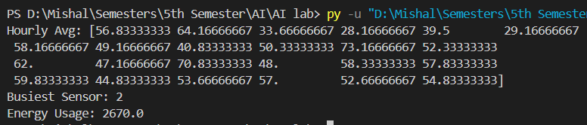

Question 10:
You are simulating forces in a mechanical system.
Task:
- Compute transformed forces: F_new = F × T
- Compute magnitude of each force vector
- Identify the component experiencing highest transformed force
- Perform eigenvalue decomposition of T
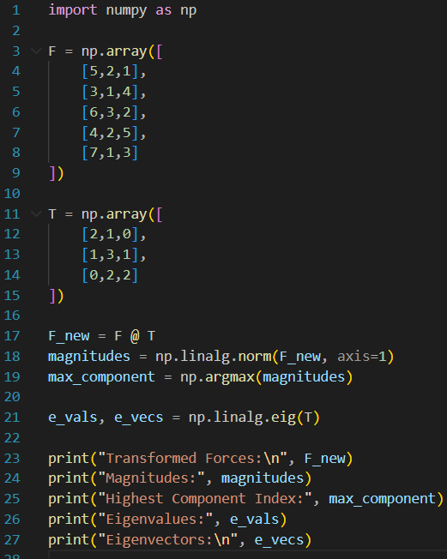

Output:
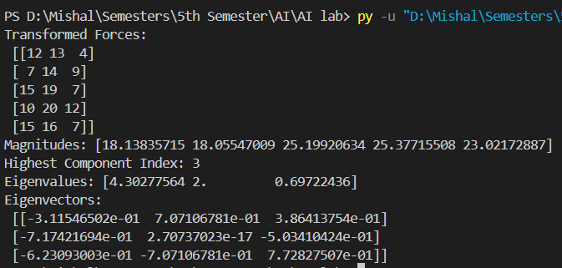
Lab NO 4
Seaborn , Scikit - learn
Part A: Seaborn
What is Seaborn?
Seaborn is a Python library for data visualization built on top of Matplotlib. It makes it easier to create statistical graphics with beautiful default styles and color palettes.
Key Features:
- Simple functions to create bar plots, line plots, histograms, boxplots, heatmaps, etc.
- Supports statistical visualization (like correlation, regression plots).
- Works well with Pandas DataFrames.
How it works:
- You provide data (usually in a Pandas DataFrame).
- Choose the type of plot you want.
- Seaborn automatically handles colors, scales, and axes to make it visually appealing.

Q1. Patient Stay Analysis (Healthcare)
You are given a dataset containing age, disease_type, and hospital_stay_days.
Write a Python program using Seaborn to:
- Plot the distribution of hospital stay days
- Compare hospital stay across different disease types
- Identify which disease has the highest median stay

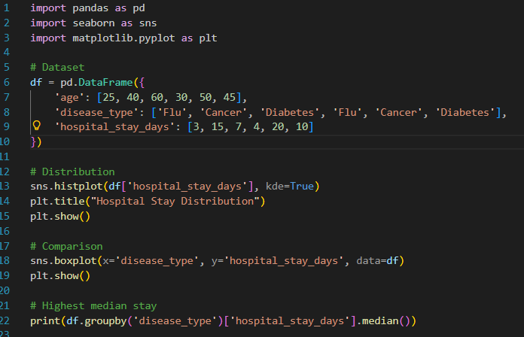
Output:
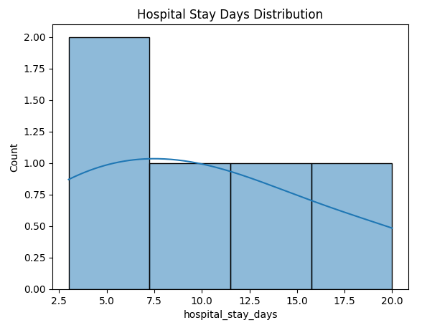

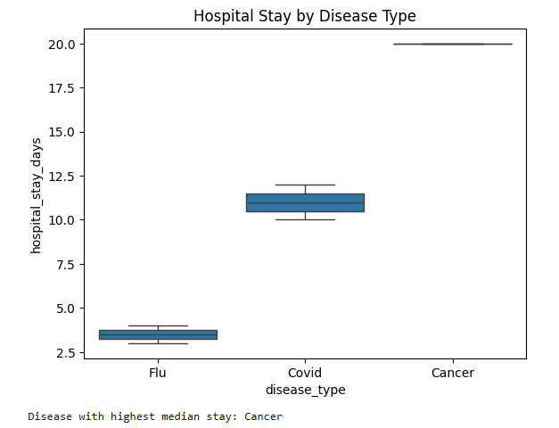

Q2. Sales Distribution Comparison (Business)
A retail dataset contains region and monthly_sales.
Write code to:
- Visualize sales distribution per region using Seaborn
- Detect regions with high sales variability
- Label the axes and add a title
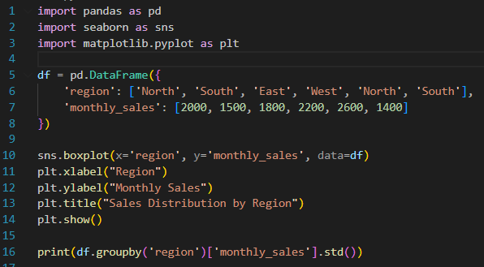
Output:

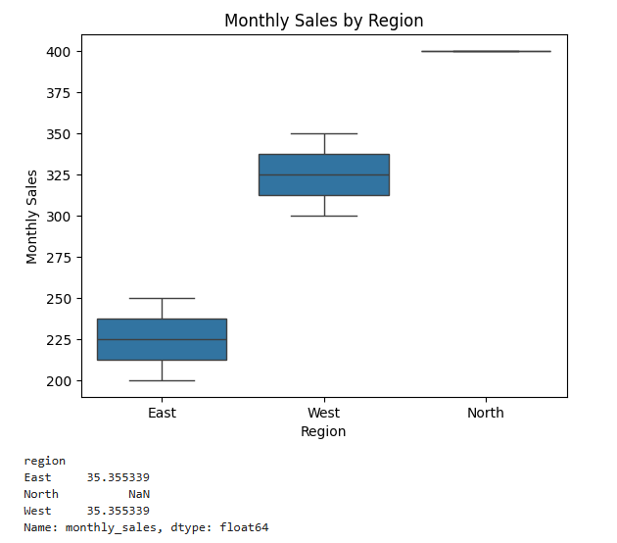

Q3. Student Performance Correlation (Education)
A dataset contains study_hours, attendance, and final_score .
Using Seaborn:
- Create a pair plot

- Plot a correlation heatmap
- Interpret which feature most affects the final score
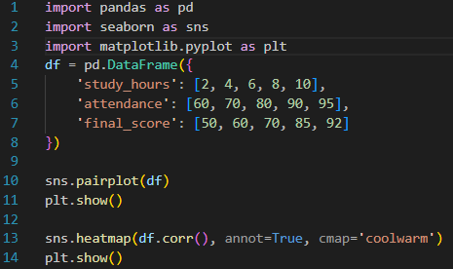
Output:
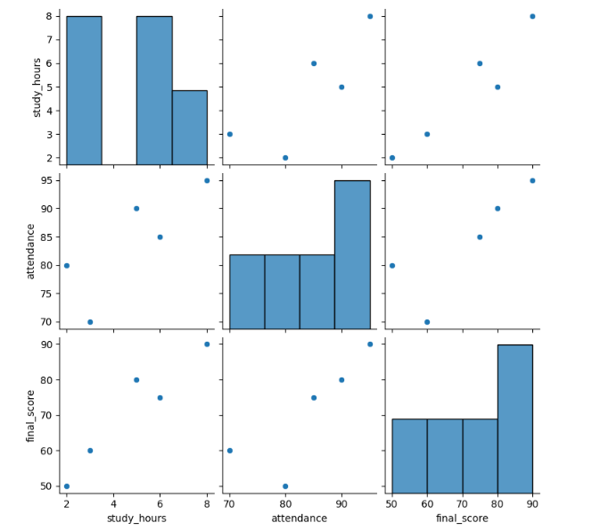
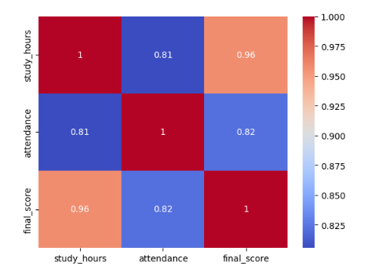

Q4. Customer Segmentation Visualization
Customer data includes age, annual_income, and spending_score.
Write a program to:
- Visualize relationships using Seaborn scatter plots
- Color-code points based on spending score
- Identify potential customer segments visually
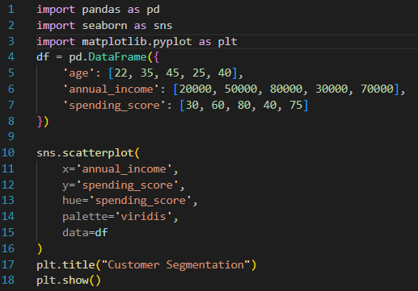
Output:
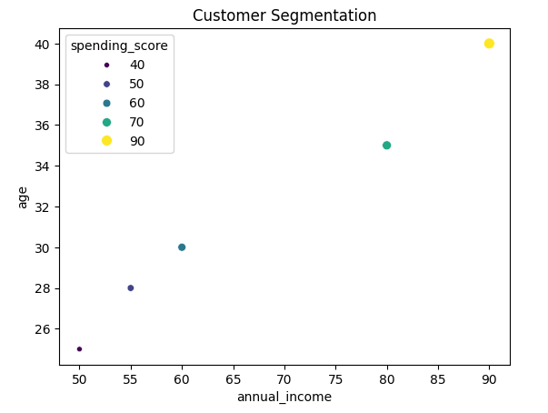

Q5. Model Result Visualization
You trained a classifier and obtained y_true and y_pred.
Write code using Seaborn to:
- Plot a confusion matrix heatmap
- Add annotations and color bar
- Clearly label predicted vs actual classes
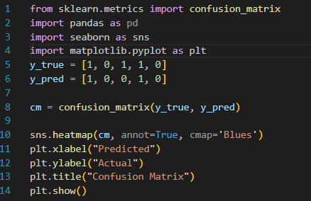
Output:
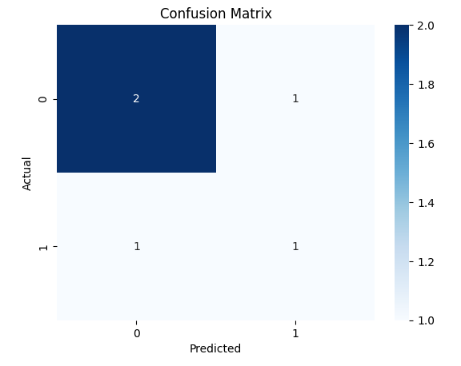
P

art B: What is Scikit-learn?
Scikit-learn is a Python library for machine learning. It provides tools for data preprocessing, classification, regression, clustering, and evaluation.
Key Features:
- Easy-to-use functions for ML algorithms: linear regression, decision trees, SVM, k-NN, etc.
- Tools for splitting data, scaling, feature selection, and model evaluation.
- Works seamlessly with NumPy and Pandas.
How it works:
- Prepare your data → Features (X) and labels (y).
- Split data → Training set & testing set.
- Choose a model → e.g., DecisionTreeClassifier.
- Train the model → model.fit(X_train, y_train)
- Predict & evaluate → model.predict(X_test), accuracy_score, confusion_matrix

Q1. Telecom Customer Churn Prediction
Given customer data with features such as tenure, monthly_charges, and contract_type, and target churn.
Write a Scikit-learn program to:
- Encode categorical variables
- Train a Logistic Regression model
- Evaluate using accuracy and confusion matrix

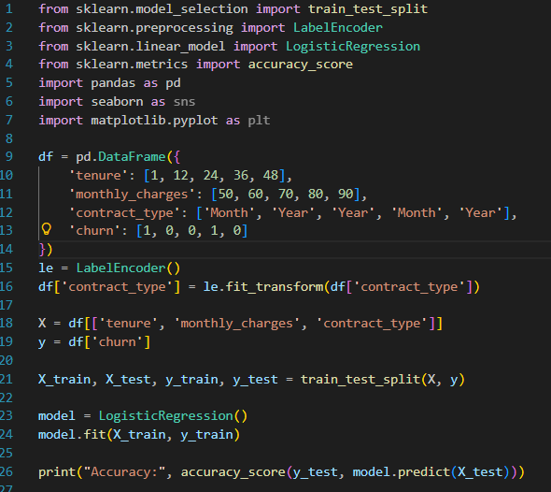
Output:

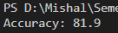

Q2. House Price Prediction
A dataset contains area, bedrooms, location_score, and price.
Implement a regression model to:
- Split data into train/test sets
- Train Linear Regression
- Predict prices and calculate Mean Squared Error

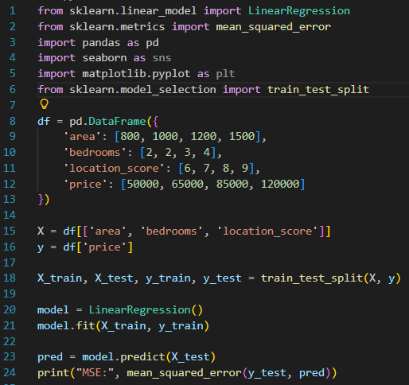
Output:

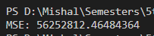

Q3. Disease Classification System
Patient data includes glucose, BMI, age, and outcome.
Write code to:
- Normalize the data
- Train a Decision Tree classifier
- Evaluate precision, recall, and F1-score

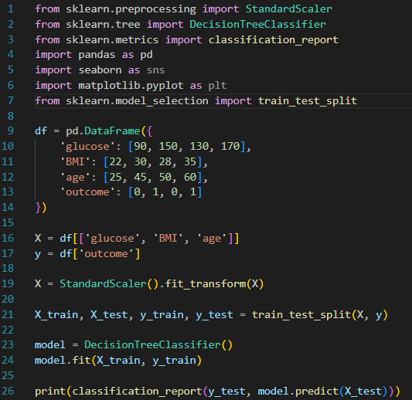
Output:
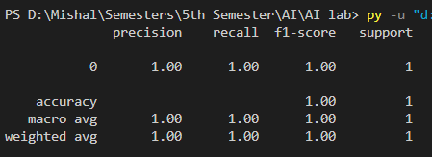

Q4. Email Spam Detection
You are given email text and spam labels.
Using Scikit-learn:
- Convert text to numerical features (TF-IDF)
- Train a Naive Bayes classifier
- Test the model on new email text

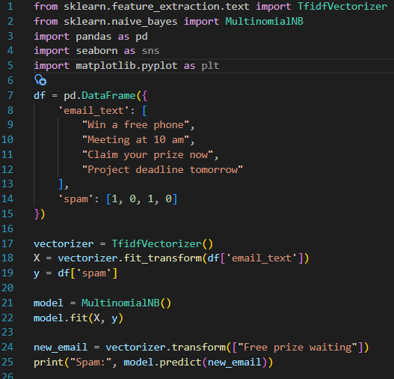
Output:
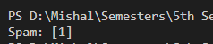

Q5. Student Risk Prediction
Student records include attendance, mid_marks, and final_marks.
Write a program to:
- Build a Random Forest classifier
- Predict whether a student is “At Risk”
- Display feature importance

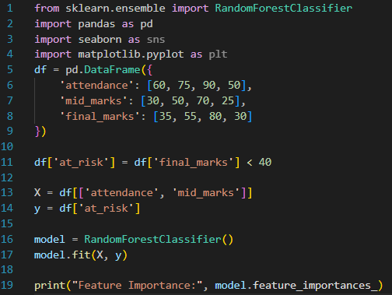
Output:

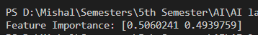

LAB NO 5
TENSORFLOW
Learning Objectives / Outcomes:
- Understand the TensorFlow library, its role in machine learning (ML) and deep learning (DL), and its main features such as multi-platform support, scalability, and model visualization using TensorBoard.
- Learn the concepts of tensors, operations, and computational graphs, and how TensorFlow performs computations using eager execution or sessions.
What is TensorFlow?
TensorFlow is an open-source library developed by Google for machine learning and deep learning. It is widely used to create, train, and deploy neural networks for tasks such as image recognition, natural language processing, and predictive analytics.
Key Features of TensorFlow:
- Multi-platform: Runs on CPUs, GPUs, mobile devices, and even web browsers.
- Flexible: Supports high-level APIs like Keras for easy and fast model building.
- Scalable: Can handle large datasets and supports distributed training across multiple devices.
- Visualization: Includes TensorBoard for monitoring and visualizing model performance.
Why is it called TensorFlow?
- Tensor: Refers to multi-dimensional data structures (like arrays or matrices).
- Flow: Represents how data flows through the layers of a neural network.
So, TensorFlow essentially means tensors flowing through operations.
Applications of TensorFlow:
TensorFlow is widely used in areas like:
- Image recognition
- Face detection
- Voice assistants
- Text classification
- Chatbots
- Medical diagnosis and analysis
- Recommendation systems (e.g., Netflix, YouTube)
- Self-driving car technology

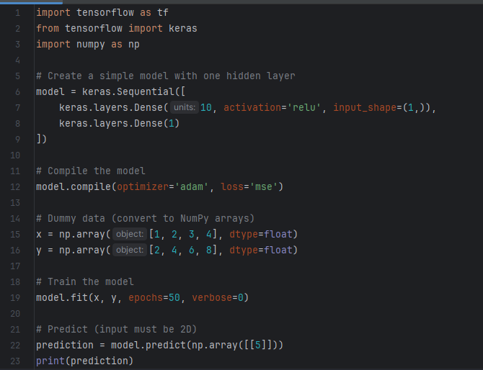
2. How TensorFlow Works
TensorFlow works with tensors, which are just multi-dimensional arrays. It builds a computation graph, where each node represents a mathematical operation, and edges represent data (tensors) flowing between operations.
Key Components:
- Tensors: Basic data structure (like arrays or matrices).
Example: Scalars (0D), Vectors (1D), Matrices (2D), etc.
- Operations (Ops): Mathematical operations applied to tensors (like addition, multiplication).
- Computational Graph: A graph representing the flow of data through operations.
- Sessions (TF1.x) / Eager Execution (TF2.x):
  - TensorFlow 1.x used sessions to run graphs.
  - TensorFlow 2.x executes operations immediately (like regular Python), making it easier to debug

Implementation:

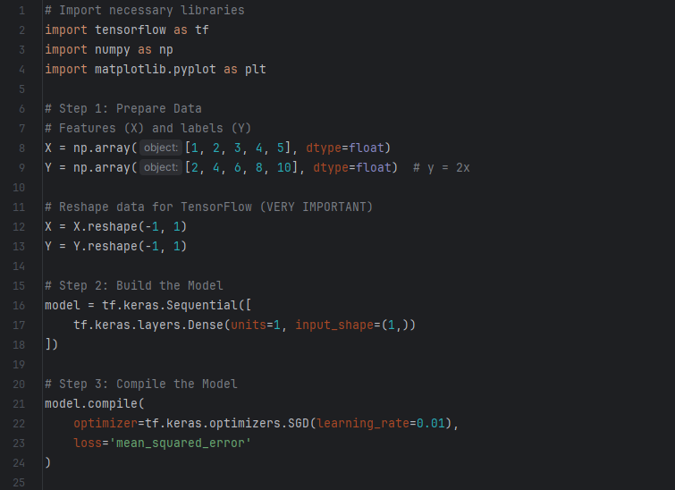
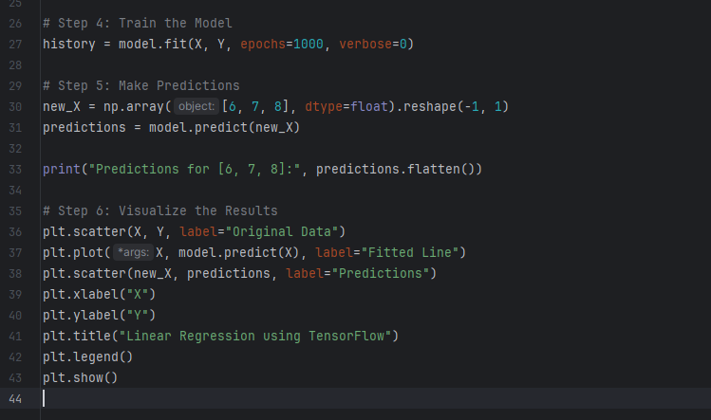

Output:
